CSD 380 Todo Business Requirements

1. Description

Todo is a business application focused on the monitoring of task items.  Users of this system are able to create, update, and delete items from their “Todo List.”  Views have been created to support most major devices and web browsers.

1. Design Requirements

1. Landing page prototype

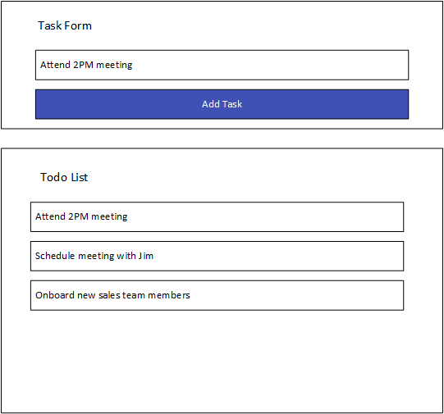

1. Edit task prototype

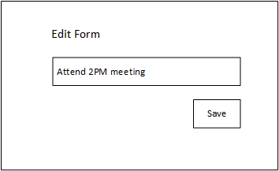

1. Functional Requirements

|  |  |  |
| --- | --- | --- |
| **Req#** | **Ranking** | **Requirement** |
| 1 | 2 | View a list of todo task items |
| 2 | 1 | Create a new todo task item |
| 3 | 4 | Edit a todo task item |
| 4 | 3 | Delete a todo task item |
| 5 | 5 | For invalid URLs, provide users with a custom 404 error page |
| 6 | 6 | Prevent users from submitting a task form with without entering a todo item |
| 7 | 7 | Prevent users from submitting the edit form without entering a todo item |
| 8 | 8 | Provide users with a view for mobile devices |
| 9 | 9 | Provide users with a view for tablet devices |
| 10 | 1 | Allow users to visit the website through <https://buwebdev.github.io/todo/> |